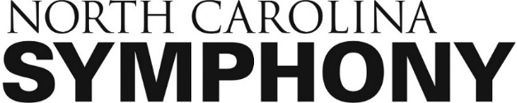
FOR IMMEDIATE RELEASE

CONTACT
Linda Charlton
919.699.8308
lcharlton@ncsymphony.org

North Carolina Symphony and The Concert Truck travel to communities to perform classical music on a mobile stage beginning October 6
The North Carolina Symphony partners with The Concert Truck to bring music directly to communities October 6 through 9, 2021, including five outdoor events with audiences able to maintain social distance while enjoying the live performances. Concerts are free to the public and families are welcome to attend.
Musicians from the North Carolina Symphony, along with The Concert Truck founding artists, Nick Luby and Susan Zhang, will perform light classical chamber music by Beethoven and Brahms, and contemporary female composers Jessie Montgomery and Caroline Shaw.
The North Carolina Symphony gratefully acknowledges the support from the North Carolina Department of Natural and Cultural Resources in conjunction with the state’s Hometown Strong Initiative.
Schedule of free concerts, open to the public:
- October 6, 4:00 pm: John Chavis Memorial Park, 505 MLK Jr Blvd, Raleigh,
NC 27601

- October 7, 4:00 pm: Wilson County Library, 249 Nash Street N, Wilson, NC
27893

- October 8, 4:00 pm: Sampson County City Market, 215 Lisbon Street,
Clinton, NC 28328

- October 9, 12:00 pm: Merchants Millpond State Park, 176 Mill Pond Rd,
Gatesville, NC 27938

- October 9, 4:00 pm: Waterfront Park, 101 W Water Street, Edenton, NC
27932

Schedule of events not open to the public:
- October 6, 12:00 pm: RISE Southeast Charter School, 3420 Idlewood Village
Drive, Raleigh, NC 27610
- October 7, 12:00 pm: Greene County Intermediate School, 614 Middle School
Road, Snow Hill, NC 28580

- October 8, 12:00 pm: Salemburg Elementary School, 404 East College Street,
Salemburg, NC 28385

